30054 International and Monetary Economics

Exam 2

June 9, 2025

Student ID ________________________________________
Name and Surname ________________________________
Class _____________________________________________

Instructions
- The exam is closed-book and lasts 60 minutes.
- You can withdraw from the exam before your 60-minute time is over.
- Do not leave your chair before the exam is declared finished.

Do not turn the page before the exam begins.

- Imagine that the initial exchange rate is 1 EUR/USD. The U.S. dollar appreciates by 1%. What is the new exchange rate in EUR/USD terms?

  - 1.01 EUR/USD
  - 1.00 EUR/USD
  - 0.99 EUR/USD
  - 0.01 EUR/USD

- Which of the following would lead to a rightward shift of the DD curve in (E, Y) space, where the exchange rate (E) is plotted on the vertical axis (with higher values at the top) and output (Y) is on the horizontal axis (with higher values toward the right)?
  - A decrease in domestic output
  - A depreciation of the domestic currency
  - A rise in domestic government purchases
  - An increase in the money supply

- According to the monetary trilemma, a country with a fixed exchange rate and no capital controls
  - sets its interest rates freely
  - allows the exchange rate to float
  - gives up independent monetary policy
  - restricts the movement of capital across borders

- The term “original sin” in international finance refers to
- pegging a currency to gold
- a country’s inability to borrow externally in its currency
- excessive public sector deficits
- the first default in recorded history

- If the domestic currency depreciates in nominal terms relative to a foreign currency while both domestic and foreign goods and services prices remain sticky in the short run, what happens to the domestic currency in real terms? In real terms, the domestic currency
  - appreciates
  - remains constant
  - depreciates
  - adjusts only if the money supply changes

- If the real exchange rate (defined using the direct approach used in class) is below one, this implies that
  - domestic goods are more expensive than foreign goods
  - domestic goods are less expensive than foreign goods
  - the country runs a trade deficit
  - absolute purchasing power parity holds

- Which of the following best explains the exchange rate overshooting covered in class?
  - Prices are fully flexible in the short run
  - The uncovered interest rate parity fails
  - Asset market prices adjust faster than goods market prices.
  - Fiscal policy dominates monetary policy

- Which of the following variables is held constant along the standard downward-sloping AA curve covered in class?
  - Current exchange rate
  - Current output
  - Money supply

- The main goal of the Bretton Woods system was to
  - eliminate cross-border trade in goods and services
  - replace gold with a floating exchange rate system
  - establish fixed (but adjustable exchange rates) and promote international financial stability by restricting capital movements
  - eliminate all capital controls between developed countries

- Assume that the standard Uncovered Interest Parity (UIP) condition holds. Suppose the domestic money supply temporarily increases, with all other factors affecting the money market and UIP unchanged. What happens to the expected rate of depreciation of the domestic currency? The expected rate of depreciation of the domestic currency
  - goes up
  - does not change
  - goes down

- Indicate whether the statement in the last sentence of the paragraph below is true or false. Provide a concise justification.

“Imagine that you are analyzing two time series (that is, the realizations of variables over time): real GDP and the money supply. You observe that the money supply varies over time, but the real GDP is constant. You must conclude that the changes in money supply do not affect output.”

FALSE. Remember that correlation does not imply causation. The observations in the statement are not sufficient to draw firm conclusions about the effects of monetary policy. For example, suppose that changes in the money supply do affect aggregate output, and that the central bank aims to stabilize output around a fixed level. In this case, whenever a shock pushes output away from that level, the central bank adjusts the money supply to offset it. As a result, we may observe fluctuations in the money supply without any change in output, despite a causal link existing.

- Indicate whether the following statement is true or false. Provide a concise justification.

“A depreciation of a domestic currency can sometimes lead to a decline in the domestic trade balance in the short run.”

TRUE. For example, due to sticky contracts, domestic currency depreciation may increase the value of imports in domestic currency without changing the quantities of exported and imported goods and services. We called this observation the J-curve.

- Indicate whether the following statement is true or false. Provide a concise justification.

“If the market value of a central bank’s assets falls below the value of its liabilities, the central bank must default.”

FALSE. Central banks are different from traditional banks. In most countries, the central banks are branches of the government. In some other countries (e.g., the United States), central banks are privately owned, but they generally act as a branch of the government. As a result, whenever the central bank generates profits, it sends them to the finance ministry. When the central bank incurs losses, such that the assets' value becomes less than the liabilities' value, the finance ministry can recapitalize the central bank.

- Indicate whether the following statement is true or false. Provide a concise justification.

“A weaker (depreciated) currency is a sign that the economy is doing badly.”

FALSE. Counterexample: Imagine the economy is growing at a normal pace and inflation is around its target. Then, the central bank out of nowhere decides to increase the money supply temporarily. It would lead to a depreciation (weakening) of the domestic currency. In this case, the weak currency is a sign of a specific monetary policy and not the state of the economy.

- Give at least one reason why firms involved in international trade often choose to price their goods and services in U.S. dollars, even if they are not based in the U.S. and do not trade directly with U.S. partners.

In class, we covered the following three ideas:
  - FX risk in supply chains: Much of international trade is in intermediate goods. If my firm uses intermediate inputs priced in dollars, then I have incentives to set and keep prices sticky in dollars as well. This reduces my FX risk.
  - Strategic complementarities in price setting: If my competitor sets prices in dollars, I also have incentives to set prices in dollars to avoid unwanted fluctuations in my prices relative to those of my competitors.
  - Finance: There is a massive demand for USD-denominated safe assets in the world. As a result, the returns on these assets are low. Hence, when I set my prices in USD, I can use my invoices as collateral when borrowing at a lower rate in USD.

- Imagine that we want to estimate the following regression:

(E_{t+1}-E_t)/E_t – (R_t – R^*_t) = alpha_0 + beta_1 * (R_t – R^*_t) + epsilon_{t+1},

where E_t is the exchange rate in period t (denoted using the direct approach as in class), R_t and R^*_t are home and foreign safe short-term nominal interest rates between periods t and t+1, epsilon_{t+1} is the error term, and alpha_0 and beta_1 are the coefficients to be estimated.

Which value of the beta_1 coefficient do you expect to estimate if the UIP condition holds and the investors' beliefs about the future exchange rate are on average correct (in other words, the investors have rational beliefs)?

  - Positive
  - Zero
  - Negative

- Suppose we estimate the same regression as in the previous question. What value would you expect for the alpha_0 coefficient if the UIP condition holds and investors have rational expectations—that is, their forecasts of future exchange rates are correct on average?

  - Positive
  - Negative
  - Zero

- Countless studies have found that the estimate of beta_1 is negative for different currency pairs and different periods. See, for example, the table below.

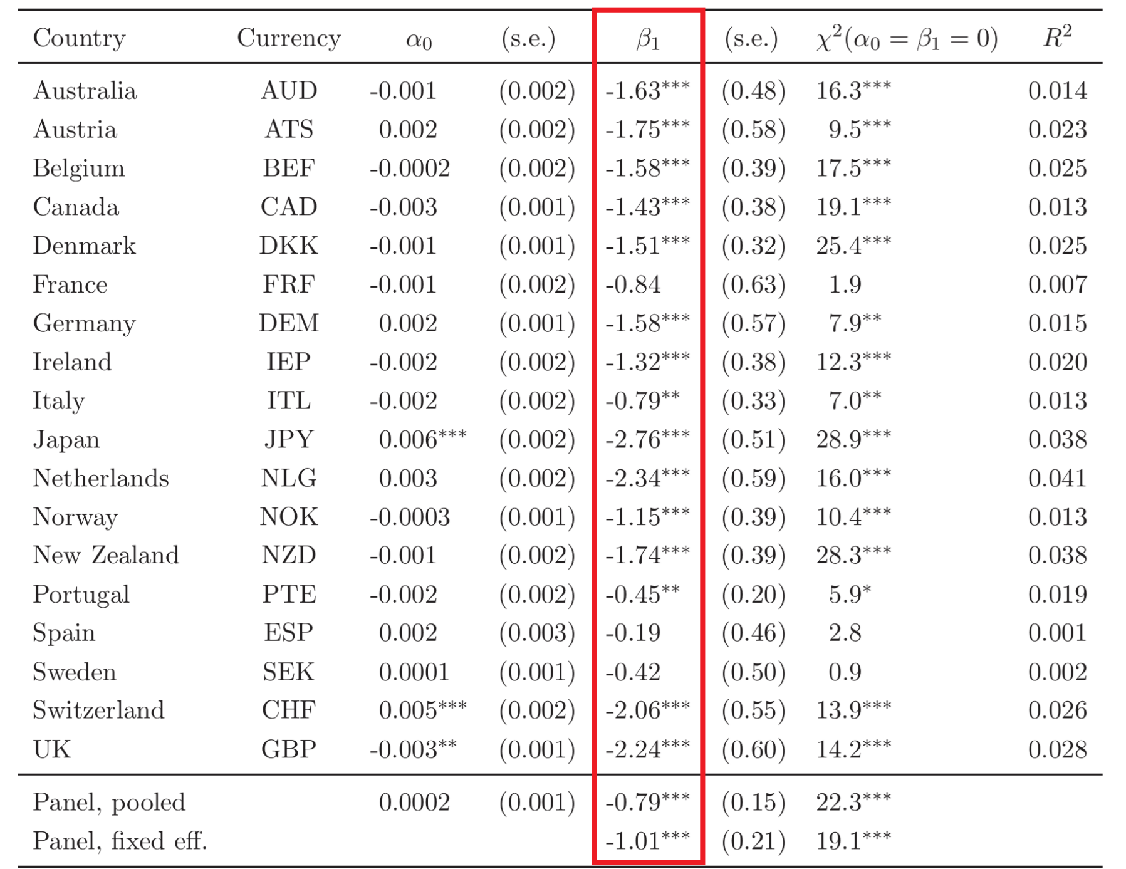

Speculate why the beta_1 coefficient is negative. Hint: Use ideas covered in class.

Consider the UIP condition, extended to include the risk premium covered in class.

(E_{t+1}-E_t)/E_t – (R_t – R^*_t) = -\rho(B-A)

If we do not control for this risk premium in our regression, but its variations affect the interest rate differential, then we could observe a non-zero correlation between the dependent variable (E_{t+1}-E_t)/E_t – (R_t – R^*_t) and the independent variable (R_t – R^*_t). For example, looking at the extended UIP condition, an increase in the risk premium \rho(B-A) will mechanically lead to a decline in (E_{t+1}-E_t)/E_t – (R_t – R^*_t), which will partly result in a decline in (E_{t+1}-E_t)/E_t and partly in an increase in (R_t – R^*_t). Hence, a decline in (E_{t+1}-E_t)/E_t – (R_t – R^*_t) is associated with an increase in (R_t – R^*_t), that is, the coefficient \beta_1 is negative.

- Consider the standard money market equilibrium discussed in class. Imagine the central bank increases the money supply, all other variables in the economy remain unchanged, and the zero (or effective) lower bound on the nominal interest rate does not bind. How does the nominal interest rate change following this policy?

  - The nominal interest rate falls
  - The nominal interest rate does not change
  - The nominal interest rate increases

- Explain intuitively where the zero lower bound on the short-term nominal interest rate comes from.

Because there is cash---a nominal safe security that pays zero interest rate---people would prefer to invest in cash if the interest rate on safe nominal bonds falls below zero.

- Which of the following tools does the Federal Reserve (the central bank of the United States) use to influence the short-term nominal interest rate (Federal Funds Rate) when the money demand is saturated (that is, the money supply is so large that people are indifferent between holding money and short-term Treasuries)?

  - Interest rate on reserve balances
  - Discount window rate
  - 10-year U.S. Treasury yield
  - 30-Year Fixed Mortgage Rate

- What is the main difference between Interest on Reserve Balances (IORB) and Overnight Reverse Repo Rate (ON RRP)?
  - IORB is paid by the Federal Reserve to non-bank financial institutions, while ON RRP is paid to commercial banks.
  - IORB is a penalty rate for banks that borrow reserves, while ON RRP is the rate paid on Treasury securities.
  - IORB is paid on reserves held by depository institutions, while ON RRP is paid to a broader set of eligible counterparties, including non-bank financial institutions.
  - IORB is set by market demand, while ON RRP is determined by the Federal Open Market Committee (FOMC).

- The central banks of most advanced countries set the short-term nominal interest rate, rather than the money supply. Why is that?
  - Because interest rates are less important for monetary transmission than the money supply
  - Because changes in the money supply are easier to observe and control in real time
  - Because shocks to the money demand have made the relationship between money supply and the interest rate unstable
  - Because targeting interest rates guarantees full employment in the short run

